My Title

Our document has three sections:

Section 1:

This is the paragraph in section 1. It could be anything at all on Earth. This could be a brochure, or even an informational flyer.

Section 2:

Here is the second section of information. You can use your imagination or knowledge of your content area to come up with ideas for Section 2 content.

Section 2 even comes with a picture:

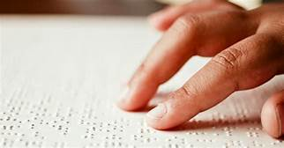

Section 3:

Let’s get a plan for making documents accessible in your area:

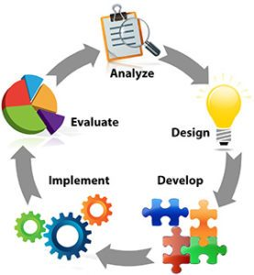

Section 5:

Our Documents

|  |  |  |  |
| --- | --- | --- | --- |
| Weekday | Word | PDF | Video |
| Monday |  |  |  |
| Tuesday |  |  |  |
| Wednesday |  |  |  |
| Thursday |  |  |  |
| Friday |  |  |  |
| TOTAL FOR THE WEEK |  |  |  |

Look at this use of color and pattern:

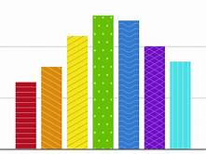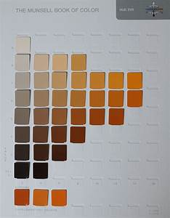

Section 6:

Here is the link to our home page at NSU: [www.nsuok.edu](http://www.nsuok.edu)

Here is a link to our employee handbook from January 2017: <https://offices.nsuok.edu/Portals/34/documents/2017%20Documents/Employment_Handbook.pdf>

Section 7:

What are floating objects?

What is white space?